Comprehensive School Safety Plan

Roosevelt Elementary School

Santa Barbara Unified School District

Christy Mendivil, Principal

1990 Laguna ST, Santa Barbara CA 93101

(805) 563-2062

cmendivil@sbunified.org

A meeting for public input held on 1/21/16 at Roosevelt website.

Reviewed by Law Enforcement on (DATE) at (location)

Plan Adopted by School Site Council 1/21/16 at Roosevelt

Plan approved by District or County Office of Education Governing Board on (by March 1)----

Committee members

Ivan Perkins, Teacher representative

Lupe Fonseca, Parent of attending student

Catherine Young, Classified employee

Name, Law enforcement-title

This document is available for public inspection at Roosevelt Elementary and on website at www.sbunified.org

**School Site Mission**

It is Roosevelt School’s mission to support our dedicated staff while providing our students with a safe, nurturing, academically challenging and an enriching educational opportunity.

**Table of Contents**

1. Assessment of the Current Status of School Crime page 3

2. Appropriate Programs and Strategies that Provide School Safety

1. Child Abuse Reporting Procedures page 3
2. Disaster Response Procedures page 3
3. Suspension and Expulsion Policies page 3
4. Procedures for Notifying Teachers about Dangerous Pupils page 3
5. Sexual Harassment Policy page 5
6. School-wide Dress Code prohibiting gang-related apparel page 5
7. Procedures for Safe Ingress and Egress from school page 5
8. Procedures to Ensure a Safe and Orderly Environment
9. *The social climate*-people and programs (Component 1) page 6
10. *The physical environment*-place (Component 2) page 7
11. Rules and Procedures on School Discipline page 8
12. Procedures adopted under the Safe and Drug-Free Schools Act page 8
13. Hate Crime Policies and Procedures page 8
14. Bullying Prevention Policies and Procedures page 8

**Assessment of the Current Status of School Crime**

Based on data compiled from the California Healthy Kids Survey, parent survey, teacher survey and school district site discipline data, there is a percentage of students who only feel close to others at school and a sense of connectedness some of the time. Forty percent of students feel that other students are well behaved only some of the time. Students do feel as though they are heard at school. Parents feel their children are safe at school.

Relationships are the foundation of a positive climate and culture. Positive relationships

need to be created and nurtured at Roosevelt. Communication between students and adults

on campus need to be positive and respectful. Clear expectations of behavior need to be

communicated.

**Child Abuse Reporting Procedures**

For specific details, refer to Santa Barbara Unified School District Board Policy and Administrative Regulation 5141.4.

[Child Abuse Prevention and Reporting - Board Policy 5141.4](http://www.sbunified.org/districtwp/wp-content/uploads/2000/01/BP5141.4.pdf)  
[Child Abuse Prevention and Reporting – Administrative Regulation 5141.4](http://www.sbunified.org/districtwp/wp-content/uploads/2000/01/AR5141.4.pdf)

**Disaster Response Procedures**

For specific details, refer to Santa Barbara Unified School District Board Policy and Administrative Regulation 3516.

[Emergencies and Disaster Preparedness Plan – Board Policy 3516](http://www.sbunified.org/districtwp/wp-content/uploads/2000/01/BP3516.pdf)

[Emergencies and Disaster Preparedness Plan – Administrative Regulation 3516](http://www.sbunified.org/districtwp/wp-content/uploads/2000/01/AR3516.pdf)

**Suspension and Expulsion Policies**

For specific details, refer to Santa Barbara Unified School District Board Policies and Administrative Regulations 5144, 5144.1 and 5144.2.

[Discipline – Board Policy 5144](http://www.sbunified.org/districtwp/wp-content/uploads/2000/01/BP5144.pdf)

[Discipline – Administrative Regulation 5144](http://www.sbunified.org/districtwp/wp-content/uploads/2000/01/AR5144.pdf)

[Suspension and Expulsion/Due Process – Board Policy 5144.1](http://www.sbunified.org/districtwp/wp-content/uploads/2000/01/BP5144.1.pdf)

[Suspension and Expulsion/Due Process – Administrative Regulation 5144.1](http://www.sbunified.org/districtwp/wp-content/uploads/2000/01/AR5144.1.pdf)  
[Suspension and Expulsion/Due Process (Students with Disabilities) – Administrative Regulation 5144.2](http://www.sbunified.org/districtwp/wp-content/uploads/2000/01/AR5144.2.pdf)

**Procedures for Notifying Teachers about Dangerous Pupils**

In order to fulfill the requirements made by Education Code 49079 and Welfare and Institutions Code 827 that state teachers must be notified of the reason(s) a student has been suspended. The SBUSD has incorporated this notification into the existing “Attendance Reporting screen”. On the daily attendance report, when a student is suspended, will show an “\*” next to the students name. The teacher can access the suspension by looking at the student’s discipline screen. Principal will notify teacher of the dates. The information provided is for the student’s current teachers only. All information regarding suspension and expulsion is **CONFIDENTIAL**, is not to be shared with any student(s) or parent(s). Teachers are asked to secure the list so students and others may not view it.

Pursuant to Welfare & Institution Code 827(b) and Education Code 48267, the Court notifies the Superintendent of the Santa Barbara Unified School District regarding students who have engaged in certain criminal conduct. This information is forwarded to the site Principal. The site Principal is responsible for prompt notification of the student’s teachers. Per Education Code 49079, this information must be kept confidential. This information is also forwarded to all administrators and the student’s counselor.

****

To: ALL CERTIFICATED STAFF

From: **Dean of Students**

Re: Student Suspension Information

*Education Code 49079 and Welfare and Institutions Code 827 require that teachers be notified of the reason(s) a student has been suspended. The SBUSD has incorporated this notification into the existing “Attendance Reporting screen”. On the daily attendance report, when a student is suspended, will show an “\*” next to the students name. The teacher can access the suspension by looking at the student’s discipline screen. The information provided is for the student’s current teachers only. All information regarding suspension and expulsion is* ***CONFIDENTIAL****, is not to be shared with any student(s) or parent(s). Teachers are asked to secure the list so students and others may not view it.*

The following are examples of Ed. Code 48900 and 48915 violations that may appear on your report.

**E.C. 48900 (a1)** Mutual fight **(a2)** Battery

**(b)** Possessed dangerous object

**(c)** Controlled substance/alcohol

**(d)** Imitation controlled substance

**(e)** Robbery/extortion

**(f)** Vandalism

**(g)** Theft

**(h)** Tobacco/nicotine products

**(i)** Habitual Profanity/vulgar or obscene act

**(j)** Drug paraphernalia

**(k)** Disruptive/willful defiant behavior

**(l)** Received stolen property

**(m)** Imitation firearm

**(n)** Sexual assault or battery

**(o)** Harassed/threatened witness

1. Sale of soma
2. Hazing
3. Bullying/cyberbullying

**(t)** Aiding and abetting \*

**E.C. 48900.2** Sexual harassment (gr 4-12)

**E.C. 48900.3** Hate violence(gr 4-12)

**E.C. 48900.4** Severe and pervasive threats and intimidation (gr 4-12)

**E.C. 48900.7** Terrorist threats

**E.C. 48915 (a1a)**Serious physical injury

**(a1b)**Possession: knife, explosive, dangerous object

**(a1c)** Controlled substance

**(a1d)** Robbery or extortion

**(a1e)** Assault/battery school employee

**E.C. 48915(c1)** Possessing, selling, furnishing firearm

**(c2)** Brandishing a knife at another person

**(c3)** Selling a controlled substance

**(c4)** Committing or attempting sexual assault or battery

**(c5)** Possession of an explosive

If you have any questions or want more information, please see me.

**Exemplar of Notification**

# Confidential

# Memorandum

**To: \_\_\_\_\_\_\_\_\_\_\_\_\_\_\_,** Teacher

**From: \_\_\_\_\_\_\_\_\_\_\_\_\_\_\_,** Principal

**Date:**

**Re: Students having committed specified crime**

The student named below has been convicted of a penal code violation.

Welfare and Institutions Code 827 requires teachers to be informed when a student has engaged in certain criminal conduct.

**NOTE: SUCH INFORMATION IS CONFIDENTIAL AND CANNOT BE FURTHER DISSEMINATED BY THE TEACHER OR OTHERS. UNLAWFUL DISSEMINATION OF THIS INFORMATION IS PUNISHABLE BY A SIGNIFICANT FINE. (EC 49079)**

**PLEASE DESTROY THIS NOTE IMMEDIATELY AFTER READING.**

\_\_\_\_\_\_\_\_\_\_\_\_\_\_\_\_ was found to have committed the following criminal activity:

If you have any questions, please see me.

Principal

**Sexual Harassment Policy**

For specific details, refer to Santa Barbara Unified School District Board Policy and Administrative Regulation 5145.7.  
[Sexual Harassment – Board Policy 5145.7](http://www.sbunified.org/districtwp/wp-content/uploads/2000/01/BP5145.7.pdf)  
[Sexual Harassment – Administrative Regulation 5145.7](http://www.sbunified.org/districtwp/wp-content/uploads/2000/01/AR5145.7.pdf)

**School–wide Dress Code prohibiting gang-related apparel**

For specific details, refer to Santa Barbara Unified School District Board Policy and Administrative Regulation 5132.

[Dress and Grooming – Board Policy 5132](http://www.sbunified.org/districtwp/wp-content/uploads/2000/01/BP5132.pdf)

[Dress and Grooming – Administrative Regulation 5132](http://www.sbunified.org/districtwp/wp-content/uploads/2000/01/AR5132.pdf)

[Dress and Grooming – Exhibit 5132](http://www.sbunified.org/districtwp/wp-content/uploads/2000/01/Exh5132.pdf)

**Procedures to Ensure a Safe and Orderly Environment**

**Procedures for Safe Ingress and Egress from School**

Roosevelt_site_map

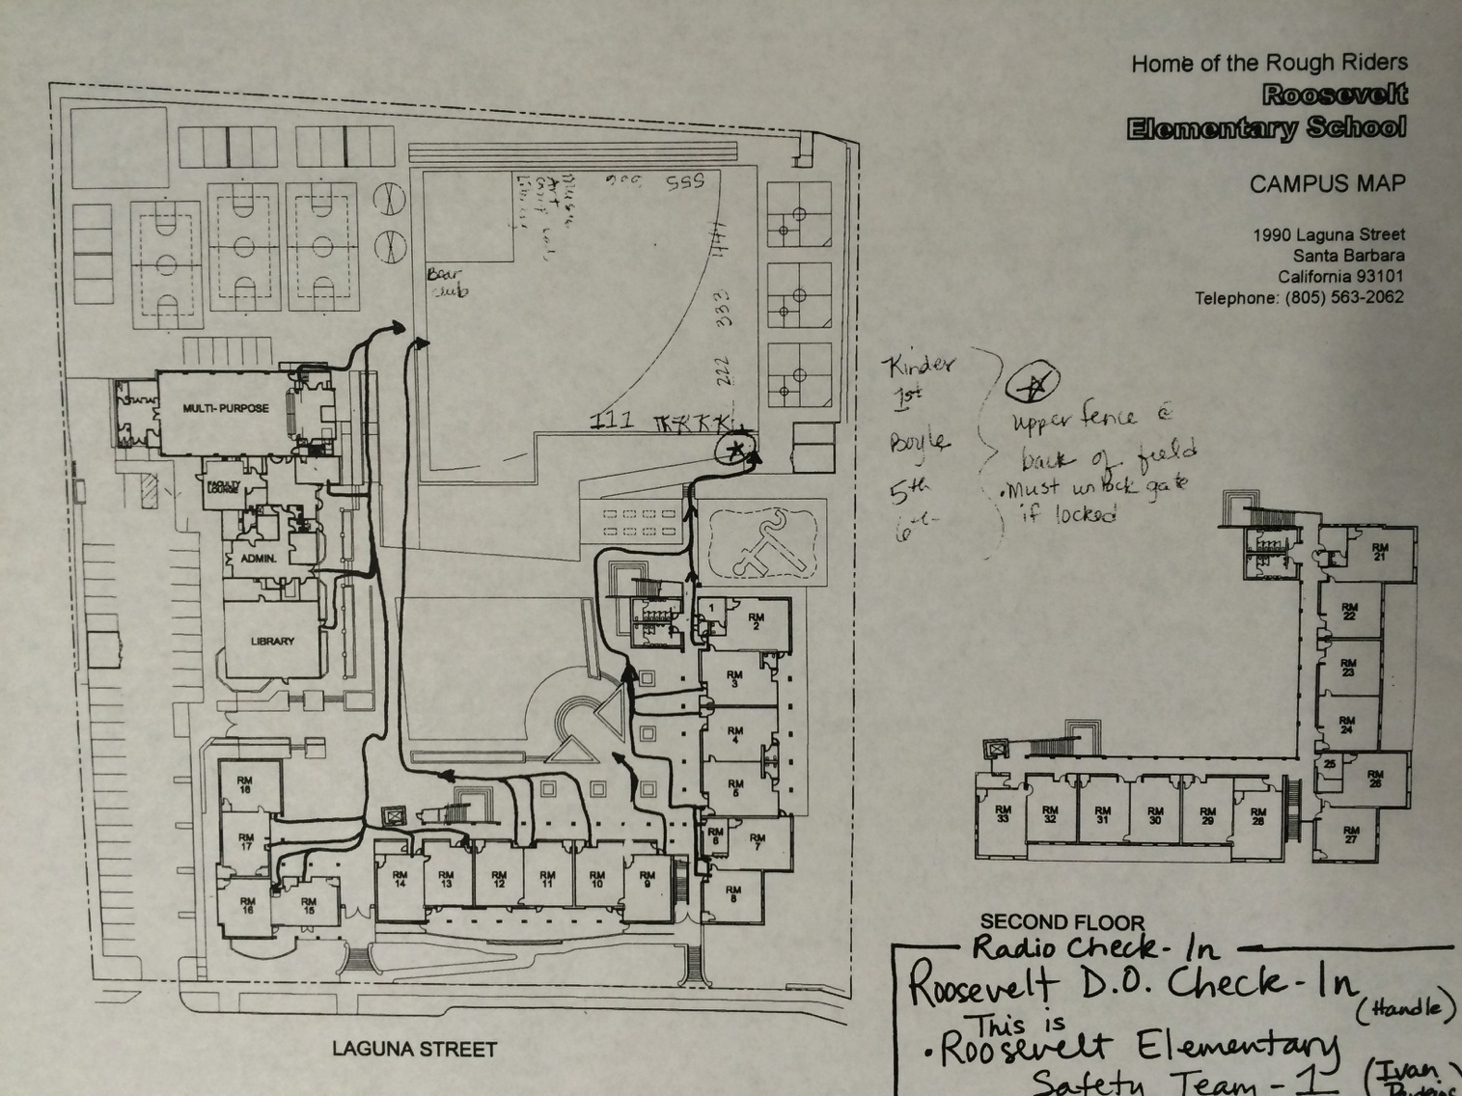

FIRE DRILL/EXIT PROCEDURES

IN THE EVENT OF A FIRE OR FIRE DRILL:

1. FOLLOW THE MAP ROUTE POSTED BY THE EXIT DOORS.
2. GRAB YOUR SAFETY FOLDER.
3. WALK IN A QUIET SINGLE FILE LINE TO THE CLASS ASSIGNED AREA OF THE FIELD.
4. COMPLETE THE ATTENDANCE RECORD.
5. HOLD UP THE GREEN OR RED CARD. (Red = attendance issue)
6. MONITOR YOUR LINE FACING THE CENTER OF THE FIELD, AND LISTEN FOR DIRECTIONS.
7. AN ADULT WILL GET THE ATTENDANCE FORM FROM YOU AS YOU ARE MONITORING THE LINE.
8. ALL STUDENTS REMAIN IN LINE UNTIL THE CODE IS GIVEN TO END THE DRILL OR EVENT.

\*Complete the following form when you don’t know where YOUR student is on campus or when you have gained a student that does not belong with you at the time of the incident.

Make copies, cut in half, and put in your fire exit folder.

STUDENT(S)

MISSING: Possible Location:

\_\_\_\_\_\_\_\_\_\_\_\_\_\_\_\_\_\_ \_\_\_\_\_\_\_\_\_\_\_\_\_\_\_\_\_\_\_\_\_

\_\_\_\_\_\_\_\_\_\_\_\_\_\_\_\_\_\_ \_\_\_\_\_\_\_\_\_\_\_\_\_\_\_\_\_\_\_\_\_

\_\_\_\_\_\_\_\_\_\_\_\_\_\_\_\_\_\_ \_\_\_\_\_\_\_\_\_\_\_\_\_\_\_\_\_\_\_\_\_

\_\_\_\_\_\_\_\_\_\_\_\_\_\_\_\_\_\_ \_\_\_\_\_\_\_\_\_\_\_\_\_\_\_\_\_\_\_\_\_

EXTRA STUDENT(S): THEIR TEACHER:

\_\_\_\_\_\_\_\_\_\_\_\_\_\_\_\_\_\_ \_\_\_\_\_\_\_\_\_\_\_\_\_\_\_\_\_\_\_\_\_

\_\_\_\_\_\_\_\_\_\_\_\_\_\_\_\_\_\_ \_\_\_\_\_\_\_\_\_\_\_\_\_\_\_\_\_\_\_\_\_

\_\_\_\_\_\_\_\_\_\_\_\_\_\_\_\_\_\_ \_\_\_\_\_\_\_\_\_\_\_\_\_\_\_\_\_\_\_\_\_

***Lockdown Procedures***

\*Teachers near restrooms (Bailey, Barr) call out to restrooms and take students to your room.

\*All teachers make sure to check the outside area around you and restrooms for any students outside of a classroom. Take any students to your room.

\*Classroom doors MUST be locked along with any doors leading to/from the outside. If you are not in your classroom, get into the nearest building.

\*\*\*ONCE YOU ARE LOCKED UP: ***DO NOT OPEN ANY DOORS DURING LOCKDOWN NO MATTER WHO CLAIMS TO BE ON THE OTHER SIDE!\*\*\****

**\*Slide red or green fire drill paper next to door inside blinds. (GREEN SIDE=ALL CLEAR IN THE CLASSROOM = no danger or health related problems…RED SIDE=PROBLEM IN THE CLASSROOM = danger or health related problem…)**

* **Gather students in the safest corner of your room. (out of sight of windows) CLOSE BLINDS.**
* **Have students remain quiet and still.**
* **Take a silent attendance.**
* **Email your attendance status (just as you would send a paper slip during a fire drill) to the designated person on the list. (This is meant for students who may have run an errand on campus, etc… who are currently missing from your classroom.**

(EXAMPLE: ALL HERE AND ACCOUNTED FOR/MENDIVIL=30/30 students)

(EXAMPLE: HAILEY MENDIVIL DELIVERED A TEXTBOOK TO A-9 =29/30 students.)

***EMAIL YOUR CLASSROOM COUNT***

***ROOMS: 1-18 19-35 Library, health office***

**Laura Wilson (office) Emily Young (office)**

[**lswilson@sbunified.org**](mailto:darvisu@yumaed.org) **&** [**eyoung@sbunified.org**](mailto:eyoung@sbunified.org)

[**cmendivil@sbunified.org**](mailto:cmendivil@sbunified.org)[**cmendivil@sbunified.org**](mailto:cmendivil@sbunified.org)

\***Custodians** will check outside area and bathrooms and then enter nearby enclosure.

\***Library**: Lock doors and follow directions.

\***PE**~Report to the nearest building immediately, if outside.

\***Office staff** Lock doors, move to secure location and check emails.

**\***Sit quietly and await instructions to “clean your desk”.

***Drill isn’t over until an administrator says the code.***

INSTRUCTIONS:

Create a plan, using the below format to make the school safer and more effective. The plan will address two factors, *The Social Climate* and *The Physical Environment* to identify your schools strengths, areas of desired change and future plans.

**Component One: People and Programs**

Create and maintain a caring and connected school climate

* Goal(s): Roosevelt Elementary staff will feel safe at work and knowhow to respond in the event

of a potentially harmful situation.

* Objective: Fire, Earthquake and Lockdown procedures are communicated and present in all

classrooms.

* + Related Activities: Safety Committee plans and reviews procedures before and after drills
  + Resources needed: committee members
  + Person(s) responsible for implementation: administrator, committee, staff
  + Timeline for implementation: ongoing
  + Budget:
  + Evaluation guidelines: review incident reports
* Goal(s): Roosevelt Elementary staff will encourage parents/guardians to volunteer in the

classroom and families to participate in school functions.

* Objective: Roosevelt staff will assist interested parties in the district volunteer process in a

timely manner

* + Related Activities: Welcome potential volunteers and communicate procedures
  + Resources needed: District support when submitting documentation
  + Person(s) responsible for implementation: staff, parents, office personnel
  + Timeline for implementation: ongoing
  + Budget:
  + Evaluation guidelines: maintain accurate documentation in office
* Goal(s): Provide programs/opportunities that promote academic success
* Objective: Improve and expand upon GATE program
  + Related Activities: Provide choice in the classroom
  + Resources needed: teacher professional development
  + Person(s) responsible for implementation: teachers, admin.
  + Timeline for implementation: ongoing
  + Budget:
  + Evaluation guidelines: assure program is being implemented
  + Related Activities: Cluster GATE identified students
  + Resources needed: teacher professional development, master schedule
  + Person(s) responsible for implementation: teachers, admin.
  + Timeline for implementation: ongoing
  + Budget:
  + Evaluation guidelines: grouping lists
* Objective: EL after school program
  + Related Activities: Imagine Learning Implemented to lower quartile EL students
  + Resources needed: teacher professional development
  + Person(s) responsible for implementation: Administrator, Imagine Learning Rep. IT support
  + Timeline for implementation: Feb. 1, 2016
  + Budget: $9,000.00
  + Evaluation guidelines: Measure student growth using program reports
* Objective: Maintain and sustain extracurricular programs on campus
  + Related Activities: Pay portion of PE teacher salary, Art teacher salary, music supplies
  + Resources needed: site funding and district support through funding, REEF funds
  + Person(s) responsible for implementation: Administrator, REEF, district personnel
  + Timeline for implementation: ongoing
  + Budget: $80,000.00
  + Evaluation guidelines: Teacher evaluation process, student participation
* Goal(s): Students and staff will promote and follow school wide expectations: Be Responsible,

Be Respectful and Be Safe

* Objective: Communicate Behavior Expectations that were created by staff
  + Related Activities: Communicate expected behaviors in all campus settings
  + Resources needed: Plan for each setting with clear procedures, teach the procedures
  + Person(s) responsible for implementation: administrator, staff, students
  + Timeline for implementation: ongoing
  + Budget:
  + Evaluation guidelines: fewer discipline referrals

**Component Two: Place**

Create and maintain a caring and connected school climate

* Goal(s): Roosevelt will maintain a safe, clean and pleasant area to meet and learn
* Objective: Staff are on duty during student recess
  + Related Activities: Meet with duty personnel quarterly to review rules and procedures
  + Resources needed: Playground rules and procedures, assigned locations
  + Person(s) responsible for implementation: Administrator
  + Timeline for implementation: quarterly
  + Budget:
  + Evaluation guidelines: review playground incident forms
* Objective: All guests to check in and out through the office during school hours
  + Related Activities: Check in and Out log and visitor stickers
  + Resources needed:
  + Person(s) responsible for implementation: Office Staff
  + Timeline for implementation: ongoing
  + Budget:
  + Evaluation guidelines: Monitor log
* Objective: Teachers have all emergency procedures in classroom
  + Related Activities: Have appropriate drills to prepare for emergency situations
  + Resources needed: Procedures, student information logs
  + Person(s) responsible for implementation: Administrator, office staff
  + Timeline for implementation: ongoing
  + Budget:
  + Evaluation guidelines: review drills after conducted to improve upon
* Objective: Areas are clean
  + Related Activities: Custodians maintain clean lunch area,
  + Resources needed: maintenance supplies
  + Person(s) responsible for implementation: Administrator
  + Timeline for implementation: ongoing
  + Budget: appropriate amount budgeted based on previous year’s needs
  + Evaluation guidelines: review playground incident forms
* Objective: Staff, students and gardening program
  + Related Activities: work in garden to maintain space
  + Resources needed: schedule
  + Person(s) responsible for implementation: Garden program representative
  + Timeline for implementation: quarterly
  + Budget:
  + Evaluation guidelines: program rubric
* Goal(s): Current materials and books will be provided to students
* Objective: Assure students have access to text and library resources
  + Related Activities: stock library, and supply classroom resources
  + Resources needed: funds, adequate resources
  + Person(s) responsible for implementation: Administrator
  + Timeline for implementation: quarterly
  + Budget: appropriate amount from district and site budget
  + Evaluation guidelines: district requirements and school checklists

**Rules and Procedures on School Discipline**

For specific details, refer to Santa Barbara Unified School District Board Policy and Administrative Regulation 5144.

[Discipline – Board Policy 5144](http://www.sbunified.org/districtwp/wp-content/uploads/2000/01/BP5144.pdf)

[Discipline – Administrative Regulation 5144](http://www.sbunified.org/districtwp/wp-content/uploads/2000/01/AR5144.pdf)

**Procedures adopted under the Safe and Drug-Free Schools Act**

For specific details, refer to Santa Barbara Unified School District Board Policy 5137.

[Positive School Climate - Board Policy 5137](http://www.sbunified.org/districtwp/wp-content/uploads/2000/01/BP5137.pdf)

**Hate Crime Policies and Procedures**

For specific details, refer to Santa Barbara Unified School District Board Policy and Administrative Regulation 5145.3.

[Nondiscrimination/Harassment – Board Policy 5145.3](http://www.sbunified.org/districtwp/wp-content/uploads/2000/01/BP5145.3.pdf)

[Nondiscrimination/Harassment – Administrative Regulation 5145.3](http://www.sbunified.org/districtwp/wp-content/uploads/2000/01/AR5145.3.pdf)

**Bullying Prevention Policies and Procedures**

For specific details, refer to Santa Barbara Unified School District Board Policy 5131.2.

[Bullying – Board Policy 5131.2](http://www.sbunified.org/districtwp/wp-content/uploads/2000/01/BP5131.2.pdf)